**“****A Study on Consumer Perception of Eco-Label Advertisement and Its Effect on Purchase Intention”**

# **EXECUTIVE SUMMARY**

This project explores how people feel about eco-labels and green advertising—and how those feelings affect what they buy. As the world becomes more aware of environmental issues, more consumers are looking for sustainable options, and companies are responding by adding “green” labels and messages to their products. But the real question is: do people trust these labels? And do they actually make different choices because of them?

To find out, I conducted a survey with 112 people from Greater Noida, focusing on their understanding of eco-labels, their opinions on green ads, and whether these things really influence their shopping habits. The results were interesting: while many people said they care about the environment and even prefer eco-friendly products, a lot of them didn’t fully understand what the labels meant. There’s also a fair amount of doubt—many respondents felt that green advertisements can be misleading or exaggerated.

Even so, there’s good news. Most participants said they were open to buying eco-labeled products in the future—and many were even willing to pay a little more for them. What really stood out was that people want **clear, honest, and easy-to-understand information**. They’re looking for brands they can trust, and they expect companies to be transparent about what makes a product “green.”

In the end, this study shows that eco-labels and green ads do matter—but they have to be done right. There’s a real opportunity for businesses to build stronger connections with consumers by being authentic and clear in their sustainability efforts. With better education and honest communication, we can help people make choices that are not just good for them, but for the planet too.

**CHAPTER-1**

**INTRODUCTION**

The global shift towards sustainable production and consumption has increased demand for eco-friendly products. Over the past few decades, significant efforts have been made to enhance these green products’ environmental efficiency and quality. As consumer lifestyles evolve, more people are becoming concerned about how their purchasing habits impact the environment, driving a shift towards products that are more sustainable.

On the production side, companies are increasingly committed to environmental preservation, showing care for both the planet and people. They are actively working to minimize environmental harm by designing, promoting, and labeling eco-friendly products to make them more appealing to a broader consumer market. To encourage the purchase of these environmentally responsible products and promote sustainable consumption, companies are looking for effective ways to communicate with consumers, helping them make more informed choices. One common strategy for achieving this is green advertising, which raises awareness about environmental issues, encourages the purchase of green products, and strengthens a company’s eco-friendly image. Green advertising is often paired with other marketing tools to achieve both environmental and social objectives.

One such tool is eco-labeling, which serves as a transparent way to inform consumers about the environmental impact of products, showing that they are less harmful to the planet. The widespread use of eco-labels and the development of clear, reliable labeling systems can increase consumers' willingness to choose more sustainable products. Various governmental and non-governmental organizations have worked hard to make the labeling process more transparent by creating and maintaining recognizable and trustworthy eco-labeling schemes. These efforts motivate companies to innovate and continuously improve their products to reduce their environmental impact, while also gaining recognition for these improvements from official bodies.

Although the effectiveness of green advertising and eco-labeling is widely acknowledged, their impact varies across different markets. Factors like consumers’ environmental awareness, national regulations, purchasing power, and individual consumer characteristics can all influence how effective these strategies are. While this topic has received increasing attention in international research, there is still a lack of empirical data in emerging countries, including the Republic of Serbia. The aim of this research is to fill this gap by examining how consumers' perceptions of green advertising and eco-labels affect their intentions to purchase eco-friendly products.

**CONSUMER’ PERCEPTION OF ECO-LABELS**

An eco-label is a symbol or sign given to a product or service that shows it has a lower environmental impact throughout its entire life cycle. This includes everything from sourcing raw materials to production, distribution, use, and disposal. Eco-labels are part of a voluntary approach to environmental regulation, and they are used to highlight products that meet certain environmental standards and have a smaller ecological footprint compared to similar products.

Today, there are many different types of eco-labels, each focusing on different aspects of environmental performance. These can include labels for organic products, animal welfare standards, resource conservation, and fair trade. For companies, eco-labels offer several advantages. As environmental concerns rise globally, obtaining an eco-label is an essential part of a company’s marketing strategy. Eco-labels help differentiate products in the marketplace and serve as an important communication tool, signaling to consumers that a product is more eco-friendly than others.

Eco-labels are often used alongside other marketing techniques, especially green advertising. When used together, eco-labels enhance the credibility of green advertisements, making the environmental claims of a company seem more trustworthy and persuasive. This combination strengthens the company's image as one that genuinely cares about environmental protection.

There is increasing evidence that eco-labels can influence consumers’ purchasing decisions. For shoppers, these labels play an important role by acting as clear signals to choose environmentally friendly products. They help consumers compare similar products from different brands by providing reliable guidance on the environmental benefits of each option.

The biggest advantage of eco-labels is their convenience, visibility, and simplicity. When eco-labels are visible on products, they make it easier for consumers to find and choose sustainable options without needing to research every product in detail. This increased access to environmental information helps raise consumer awareness and encourages them to make more eco-friendly purchases. In short, eco-labels not only provide useful information but also make it easier for consumers to support the environment with their purchasing choices.

Top of Form

Bottom of Form

**GREEN ADVERTISING AND ITS INFLUENCE ON PURCHASING**

With growing public interest in environmental issues around the world, companies have increasingly turned to green advertising as a way to communicate the eco-friendly features of their products, encourage responsible consumer behavior, and highlight their commitment to sustainability. Green advertising includes messages that focus on environmental sustainability, eco-friendly production practices, and the overall environmental impact of products. By using this approach, companies can create a strong competitive advantage and demonstrate their dedication to preserving the planet.

The main goal of green advertising is to inspire consumers to consider buying products that are less harmful to the environment. It aims to influence their purchasing behavior by making them more interested in products that contribute to sustainability. Green advertising also helps raise consumer awareness by educating people about their role in environmental preservation and encouraging them to make more environmentally responsible choices.

Research has shown that green advertising can effectively shape consumers' attitudes toward eco-friendly products and motivate them to act in ways that benefit the environment. This kind of advertising is often used to highlight the positive impacts of purchasing products with a lower environmental footprint, helping consumers understand the benefits of their choices.

While there is growing evidence that green advertising can positively influence consumers' intentions to buy more sustainable products, its effectiveness isn't universal. Consumers’ responses to green advertising can vary greatly from person to person. In some cases, people may resist changing their established purchasing habits or may not want to make the extra effort to find and buy sustainable products. Other factors, like individual traits, personal values, and skepticism, can also play a role in how consumers respond to green advertising.

For companies, this creates a challenge in crafting the most effective green advertising messages. The complexity of consumer behavior, along with the many factors influencing responses to green advertising, makes it difficult to find a one-size-fits-all solution for promoting environmentally friendly products.

**CHAPTER-2**

**LITERATURE REVIEW**

The focus on sustainability in our modern world and the rise in concern about environmental issues have shifted consumers’ behavior. In response to the increased demand for environmentally friendly products, businesses are modifying their marketing frameworks to capture the attention of green consumers. One important strategy that seems to be working well is the application of eco-labels and green advertising. Eco-labels are defined as labels that grant a product or service specific criteria under which they are considered environmentally favorable. This serves as proof a consumer can identify with protection for the environment. Such labels play a critical role in fostering sustainable consumption behavior..

In this literature review, I analyze what existing studies say about eco-label advertisements and their effects on consumer perceptions and purchase intentions. It addresses how consumers view eco-labels, the factors that form these perceptions, and how eco-labels ultimately influence purchase decisions. Understanding this complex is important for businesses, marketers, and policymakers from an environmental sustainability perspective, especially with the rise in demand for sustainable products..

.

**( Kolović, T., Vlastelica, T., & Krstić, J. (2023). Consumers ‘Perception of Green Advertising and Eco-Labels: The Effect on Purchasing Intentions. *Marketing (0354-3471)*, *54*(1).**

With the advancement of green advertising and the use of eco-labels, the increasing concern regarding ecological degradation has grown more than ever. This study aimed at how consumers' perceptions of green advertising and eco-labels influence their purchasing decisions regarding eco-labeled products. The analysis is based on an online survey with 172 participants from Serbia, the findings showed that the majority of respondents were aware of environmental challenges and expressed concern, but they did not consistently consider the ecological impact of their purchasing choices.

This research emphasized the significant relationship between pro-environmental behavior and factors like receptiveness to green advertising, attitudes towards it, and perceptions of eco-labels. People who were more receptive to green advertising and had a positive attitude towards it were more inclined to purchase products with eco-labeled. Nonetheless, the study also found that the respondents' understanding of eco-labels did not significantly affect their purchasing intentions. This impact was mostly due to a lack of familiarity with environmental product labeling

( **Dr. Kanchana P, 2024)**

As environmental challenges become more urgent, green marketing has become a key strategy for promoting sustainability. This study aims how consumer perceptions and brand strategies intersect to encourage eco-friendly behaviors. It examine how sustainability-focused initiatives impact consumer decisions and how green marketing can enhance brand loyalty and reputation. Major constitutes like environmental awareness, trust in green claims, and cultural influences play a major role in eco-conscious purchasing decisions.

From a business perspective, the paper examines how companies are incorporating green marketing into their branding efforts, focusing on approaches like clear communication, sustainable packaging, and adopting circular economy practices. It also addresses challenges like accusations of greenwashing and the balance between making a profit and staying committed to genuine sustainability.

Understanding how different technologies, such as AI and big data, influence consumer behavior in order to develop effective green marketing strategies is also highlighted. The paper places great emphasis on the importance of ethical standards and regulatory compliance to build trust with consumers and create lasting relationships.

By combining recent research and industry practices, this paper provides new perspectives for businesses navigating the world of green marketing. It concludes that collaboration between businesses, policymakers, and consumers is essential to reaching sustainability goals while fostering positive brand relationships. Ultimately, it offers an outline for using green marketing as a powerful tool for driving sustainable consumerism and supporting environmental behavior.

**Verleye, G., De Ruyck, A., Vermeulen, W., & Schoenaers, I. (2023). Credibility of green advertising: six elements that drive credibility in green advertising. *Frontiers in Communication*, *8*, 1056020**.

This research aimed to explore how credible Belgian consumers find sustainable advertising messages and how credibility impacts the effectiveness of green ads. The study discerned six primary dimensions that constituted credibility in green advertising: honesty, clarity, detail, commitment, urgency, and shared values. In order to validate these components, a survey was conducted with 600 Belgian respondents, who viewed five sustainable commercials randomly selected from a collection of 95 aired in Belgium over the last two years.

The findings indicate that credibility is one of the most important factors affecting green advertising’s success. The six elements of credibility explained 72% of the credibility in green ads, and together they accounted for 59% of consumers' motivation to choose sustainable products over conventional ones. These factors also accounted for 28% of the brand consideration for advertised sustainable products. The study suggests that for green advertising to be effective, it must be honest, committed, urgent, clear, detailed, and focused on shared values between companies and consumers.

Additionally, the research lays the groundwork for an app that can predict brand consideration based on these credibility factors, given their high explanatory power. Ultimately, the future success of sustainability efforts may depend on brands’ ability to shift consumer mindsets with credible green advertising.

.

**Patel, C., & Chugan, P. K. (2015). The influence of consumer perception towards green advertising on green purchase intention. *International Journal of Entrepreneurship & Business Environment Perspectives*, *4*(3), 1865-1873.**

Green marketing has gained significant importance since the 1970s, accelerating in recent decades as consumer awareness of environmental issues has grown. Many companies have adapted their products and processes to position themselves as environmentally friendly, using advertising as a key tool to promote their green image and influence consumer perceptions. As a result, understanding how consumer perceptions of green advertising affect purchase behavior has become crucial for companies’ strategies.

This study aimed to explore how consumers’ perceptions of green advertising influence their intention to purchase green products. The research quantified consumer perceptions and purchase intentions using pre-existing literature, and analyzed the data through factor analysis and multiple regression. The results show that factors such as environmental knowledge, company image, product improvements, and ethical impact positively influenced consumers’ intention to purchase green products. However, skepticism towards green claims and the perceived credibility of green ads remained neutral towards the purchase intention.

These results offer valuable insights for marketers, highlighting the key aspects of green advertising—such as focusing on environmental knowledge, company reputation, and ethical messaging—that can help shape effective advertising strategies and encourage green purchases.

Bottom of Form

**CHAPTER-3**

**OBJECTIVES OF RESEARCH PAPER**

**Primary Objective:**

This research aims to understand how people's views on green advertising and eco-friendly labels affect their decision to buy environmentally friendly products .

**Secondary Objective:**

To evaluate the role of eco-label perception in influencing purchasing decision

**CHAPTER-4**

**RESEARCH METHODOLOGY**

* **Research Objective**:

Primary Objective

This research aims to understand how people's views on green advertising and eco-friendly labels affect their decision to buy environmentally friendly products .

Secondary Objective

To evaluate the role of eco-label perception in influencing purchasing decision

* **Sampling Technique**:

The research paper used a **non-probability convenience sampling technique**. Specifically:

* The study collected data through an **online survey**.
* The sample consisted of **112 consumers from Greater Noida**
* The participants were selected through a **convenient sampling method**, meaning they were chosen based on ease of access.
* The survey invitation was distributed via **social media and LinkedIn**.
* **Target Population**:
* The sample consisted of **112 consumers from Greater Noida**
* **Data Collection Method**:

Survey Questionnaires

**CHAPTER-5**

**DATA ANALYSIS**

**Table 5.1 Respondent age group.**

|  |  |
| --- | --- |
| Age | Percentage |
| Below 18 | 0.9% |
| 18-25 | 37.5% |
| 26-35 | 29.5% |
| 36-50 | 27.7% |
| 50 and above | 4.5% |

The age distribution of **112 respondents** suggests a majority in the **18–25 age group**, highlighting young consumers' views on green advertising and eco-labels. Their attitudes may differ from older generations, affecting purchasing behavior. Limited representation of older groups could impact the study's generalizability across diverse age demographics.

**Figure 5.1 Represent the Frequency of the age group using a Pie graph**

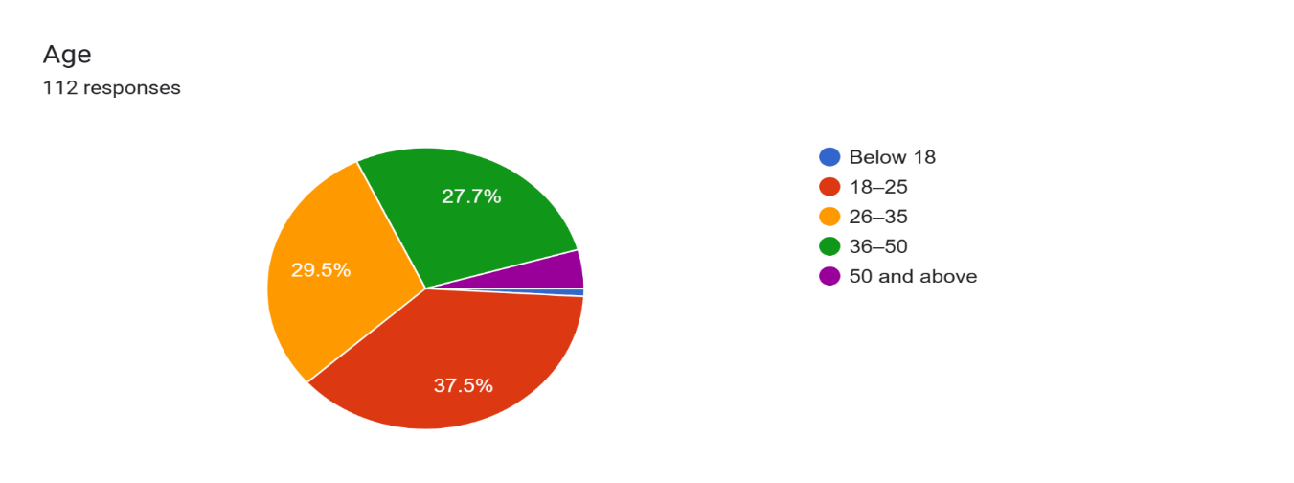

**Table 5.2** **Gender distribution as a percentage.**

|  |  |
| --- | --- |
| Gender | Percentage |
| Male | 73.2% |
| Female | 25.9% |
| Others | 0.9% |

The gender distribution of **112 respondents** shows that **73.2% are male**, **25.9% are female**, and a very small percentage falls under the "Other" category. This indicates that the study's findings may be more reflective of male perspectives, potentially influencing the interpretation of consumer attitudes toward eco-label advertising

**Figure 5.2** **represents the frequency of gender distribution using a Pie graph.**

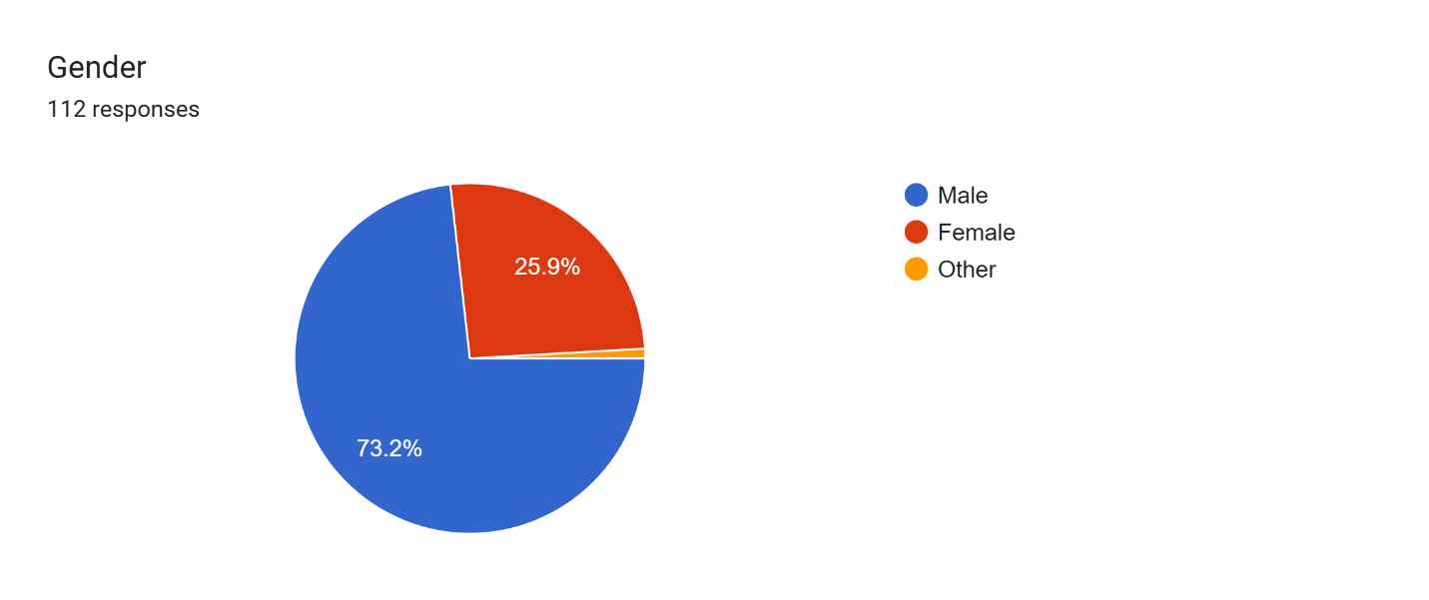

**Table 5.3 The Profession data.**

|  |  |
| --- | --- |
| **Profession** | Percentage |
| High school or below | 2.8% |
| Undergraduate Degree | 37.6% |
| Postgraduate Degree | 45% |
| Other | 14.7% |

The proportion of the population that has completed each degree of **Profession** is shown in this breakdown

**Figure 5.3 Represents frequency of Profession data using a Pie graph.**

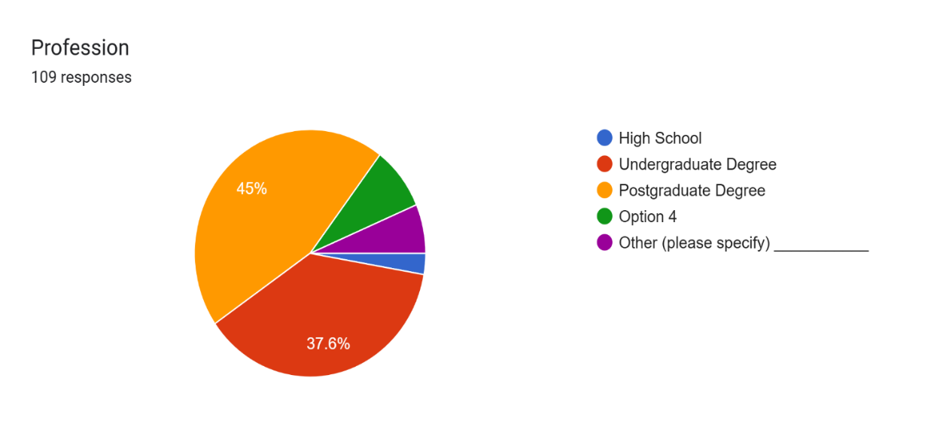

**Table 5.4 Percentage  How well do you understand the meaning of the certified eco-labels presented?**

|  |  |
| --- | --- |
| Understanding of Certified Eco-Labels | Percentage |
| Very well | 36.06% |
| Somewhat well | 40.02% |
| Not well | 17.09% |
| Not at all | 05.04% |

The data shows that while 36.6% of respondents **understand certified eco-labels very well**, a larger portion (40.2%) only **somewhat understands** them. Additionally, 17.9% **struggle to understand** them, and a small percentage **do not understand them at all**, indicating a need for clearer communication and better consumer education on eco-label meanings.

**Figure 5.4 Represents the frequency Labels Understanding of Certified Eco-label using Pie graph.**

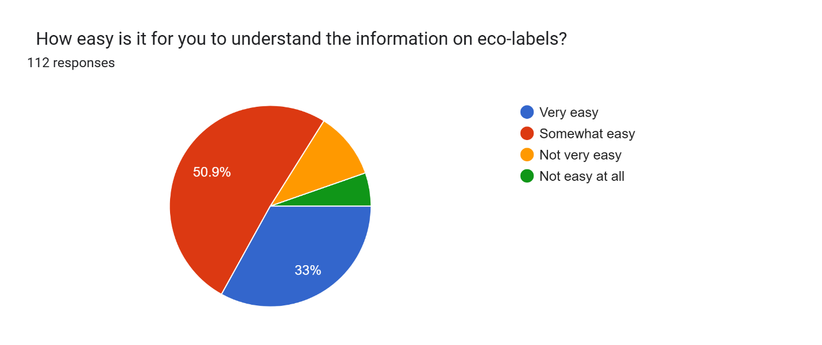

**Table 5.5 Percentage  of how easy is it for you to understand the information on eco-labels?**

|  |  |
| --- | --- |
| Understanding of Eco-Labels | Percentage |
| Very easy | 33.0% |
| Somewhat easy | 50.9% |
| Not very easy | 10.07% |
| Not easy at all | 05.04% |

The survey shows that 50.9% of respondents find eco-label information somewhat easy to understand, while 33% find it very easy. A smaller portion struggles, indicating a need for clearer labeling.

**Figure 5.5 Represents the frequency Understanding of Eco-Labels using Pie graph.**



**Table 5.6** **The percentages of how satisfied are consumer with the information currently available on the eco-labels of the products that consumer purchase.**

|  |  |
| --- | --- |
| Satisfaction Level with Eco-Label Information | Percentage |
| Very satisfied | 16.1% |
| Satisfied | 59.8% |
| Unsatisfied | 22.3% |
| Very unsatisfied | 1.8% |

The data indicates that a majority (59.8%) of respondents are **satisfied** with the information available on eco-labels, while only 16.1% are **very satisfied**. However, 22.3% are **unsatisfied**, and a small percentage is **very unsatisfied**, suggesting that while most consumers find eco-label information useful, there is still room for improvement in clarity and accessibility.

**Figure5.6 Represents the frequency of the** Satisfaction Level with Eco-Label Information **data using Pie graph.**

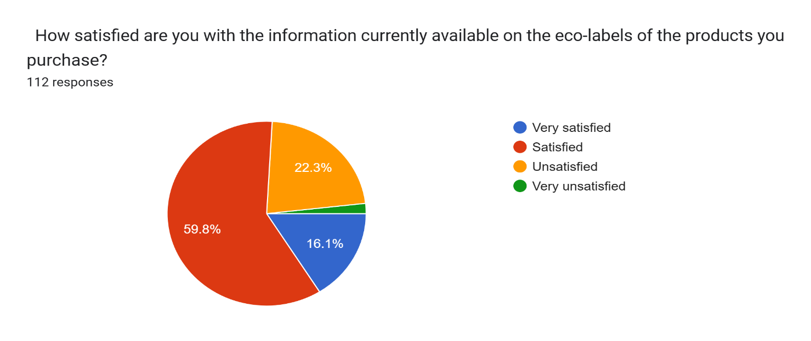

**Table 5.7 How much do you trust the accuracy of the information printed on eco-labels?**

|  |  |
| --- | --- |
| Trust Level | Percentage |
| I fully trust | 18% |
| I mostly trust | 34.2% |
| I somewhat trust | 36% |
| I do not trust | 11.7% |

The data indicates that trust in the accuracy of eco-label information is mixed. While 18% fully trust and 34.2% mostly trust the labels, a significant portion (36%) only somewhat trusts them, and 11.7% do not trust them at all. This suggests that many consumers have reservations about the reliability of eco-labels..

**Figure 5.7 represents the frequency of Trust Level using Pie graph**.

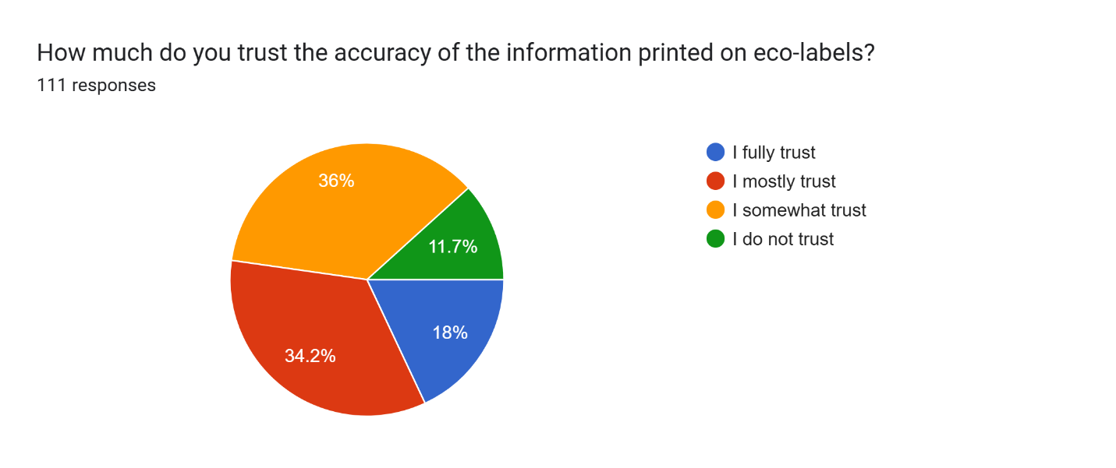

**Table 5.8 Have you ever switched products for ecological reasons?**

|  |  |
| --- | --- |
| Response Category | Percentage |
| Yes, frequently | 22.5% |
| Yes, occasionally | 47.7% |
| No, but I've considered it | 19.8% |
| No, I have never switched products for ecological reasons | |  | | --- | |  |  |  | | --- | | 9.9% | |

The data indicates that 70.2% of respondents have switched products for ecological reasons, either frequently or occasionally. However, 29.7% have either never switched or only considered it, highlighting mixed consumer commitment to sustainable purchasing

**Figure 5.8 Represents the frequency that have you ever switched products for ecological reasons using Pie chart.**

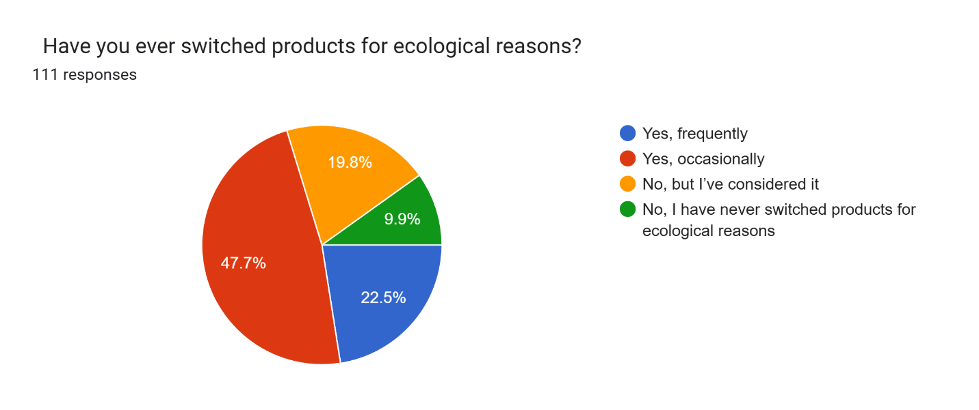

**Table 5.9 When choosing between two similar products, do you tend to purchase the one that is less harmful to the environment?.**

|  |  |
| --- | --- |
| Response Option | Percentage |
| Always | 37.8% |
| Usually | 35.1% |
| Sometimes | 19.8% |
| Never | 7.2% |

The data shows that 37.8% of consumers always choose eco-friendly products, while 35.1% usually do. However, 19.8% only consider it sometimes, and 7.2% never prioritize environmental impact in purchasing decisions

**Figure 5.9 Represents the frequency of when choosing between two similar products, do you tend to purchase the one that is less harmful to the environment using pie chart.**

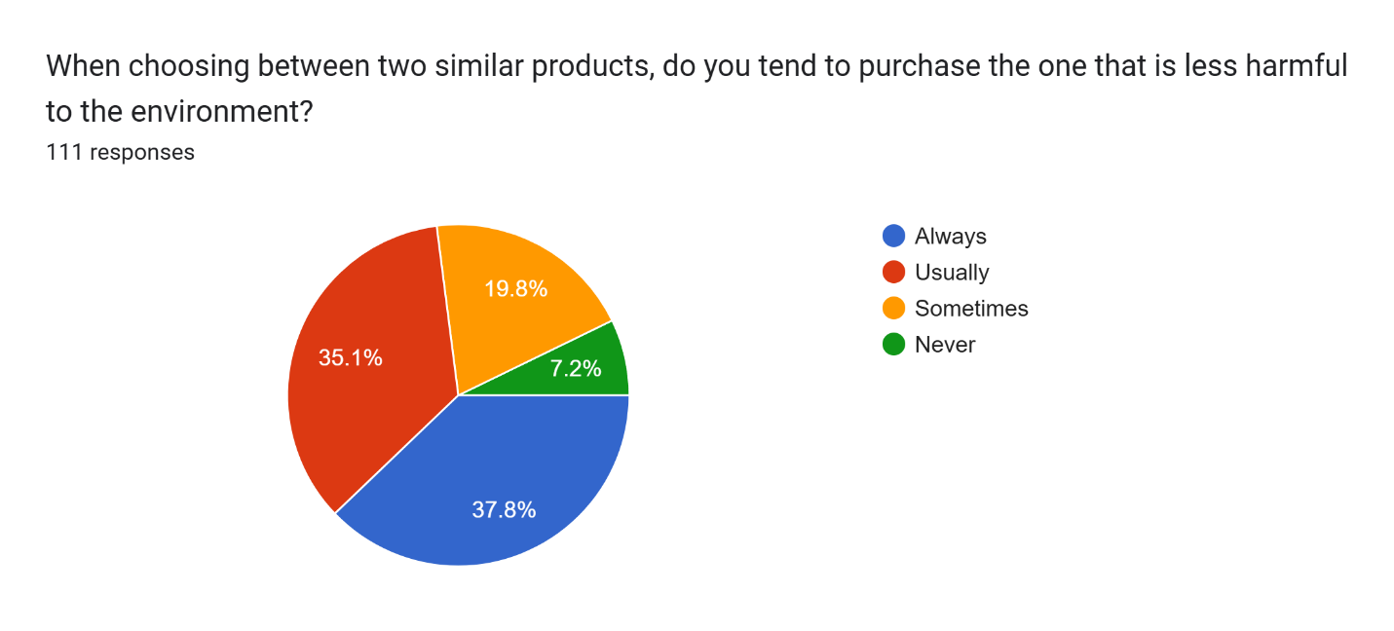

**Table 5.10 shows the percentage of   Do you read labels to check if the contents are environmentally safe?**

|  |  |
| --- | --- |
| Response Category | Percentage |
| Always | 28.8% |
| Often | 28.8% |
| Sometimes | 32.4% |
| Never | 9.9% |

The data shows that 57.6% of respondents frequently check product labels for environmental safety, while 32.4% do so occasionally. However, 9.9% never check, indicating room for increased environmental awareness.

**Figure 5.10 Represents the Do you read labels to check if the contents are environmentally safe using a Pie chart.**

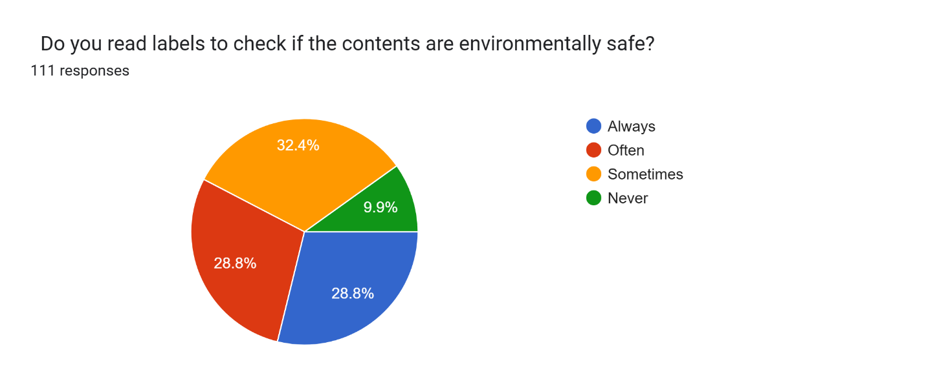

**Table 5.11 shows How do you feel about buying brands that are less damaging to the environment in percentage.**

|  |  |
| --- | --- |
| Response Category | Percentage |
| Very Positive | 54.1% |
| Somewhat Positive | 27% |
| Neutral | 16.2% |
| Not Positive | 2.7% |

The data shows that 54.1% of respondents feel very positive about buying environmentally friendly brands, while 27% are somewhat positive. Only 16.2% are neutral, and a small 2.7% are not positive.

**Figure 5.11 represents How do you feel about buying brands that are less damaging to the environment using a Pie chart.**

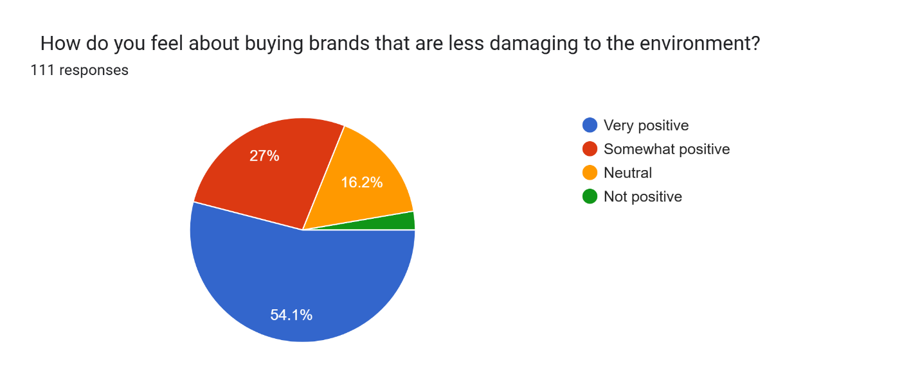

**Table 5.12 shows percentage of  How easy is it for you to identify products that are less damaging to the environment?**

|  |  |
| --- | --- |
| Response Category | Percentage |
| Very easy | 23.6% |
| Somewhat easy | 40% |
| Not very easy | 31.8% |
| Not easy at all | 4.6% |

The data shows that 63.6% of respondents find it somewhat or very easy to identify eco-friendly products, while 36.4% struggle, indicating a need for clearer labeling and consumer awareness initiatives..

**Figure 5.12 represents the frequency of How easy is it for you to identify products that are less damaging to the environment using Bar graph.**

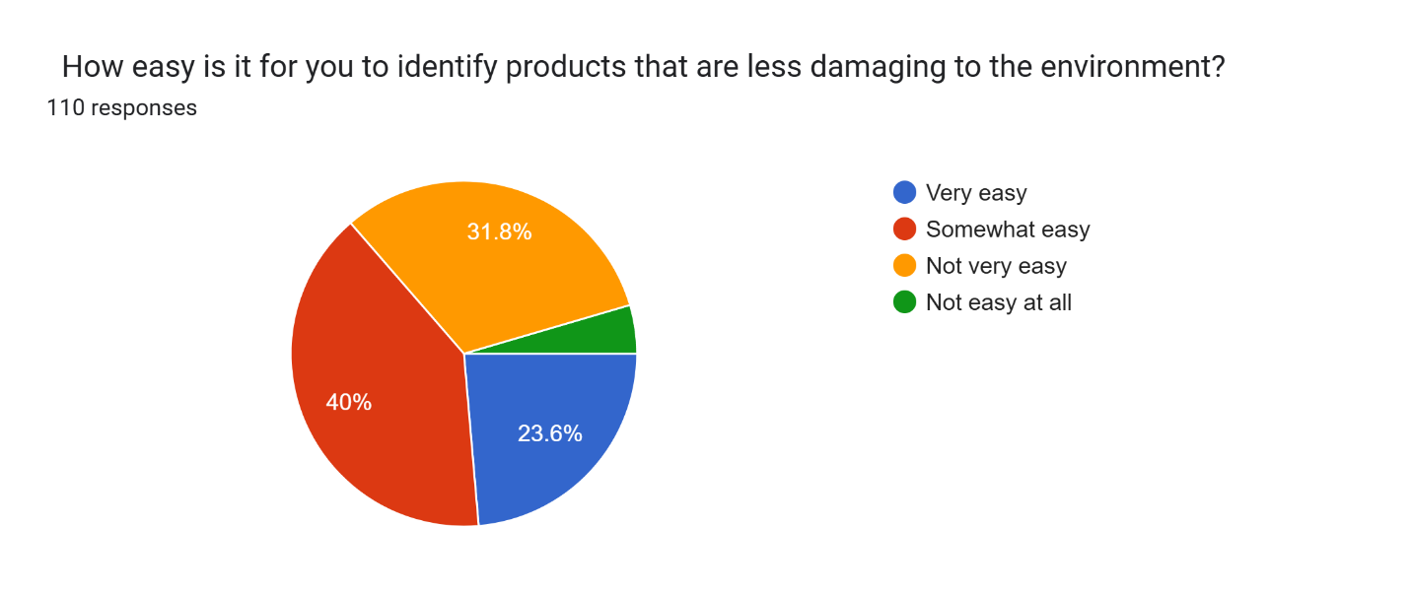

**.**

**Table 5.13 shows the percentage of   Do you believe marketers should advertise the environmental aspects of their products?.**

|  |  |
| --- | --- |
| Response Option | Percentage |
| Strongly Agree | 61.3% |
| Agree | 35.1% |
| Disagree | 2.7% |
| Strongly Disagree | 0.9% |

The data shows that 96.4% of respondents support marketing environmental aspects of products, with 61.3% strongly agreeing. This highlights strong consumer demand for transparency and eco-friendly branding in advertisements..

**Figure 5.13 represents Do you believe marketers should advertise the environmental aspects of their products using a Pie chart**

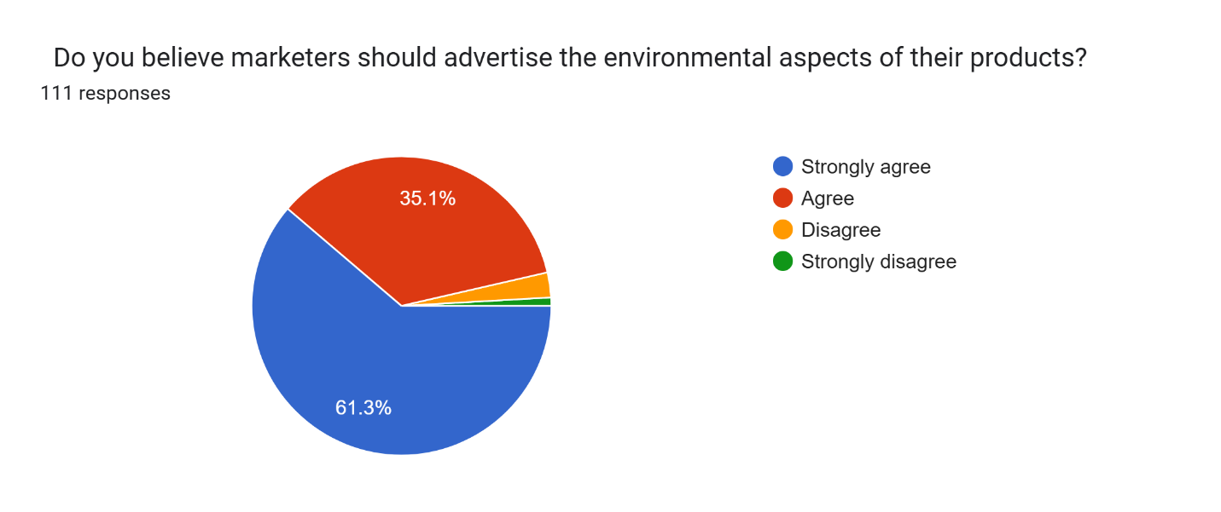

**Table 5.14 shows the percentage Do you believe green advertising is valuable?**.

|  |  |
| --- | --- |
| Response Option | Percentage |
| Strongly Agree | 53.2% |
| Agree | 42.3% |
| Disagree | 3.6% |
| Strongly Disagree | 0.9% |

The data shows strong support for green advertising, with **53.2% strongly agreeing** and **42.3% agreeing**. A small percentage disagrees, indicating that most consumers value eco-friendly marketing efforts and sustainability messaging in advertisements..

**Figure 5.14 shows the frequency of Do you believe green advertising is valuable using a bar graph**

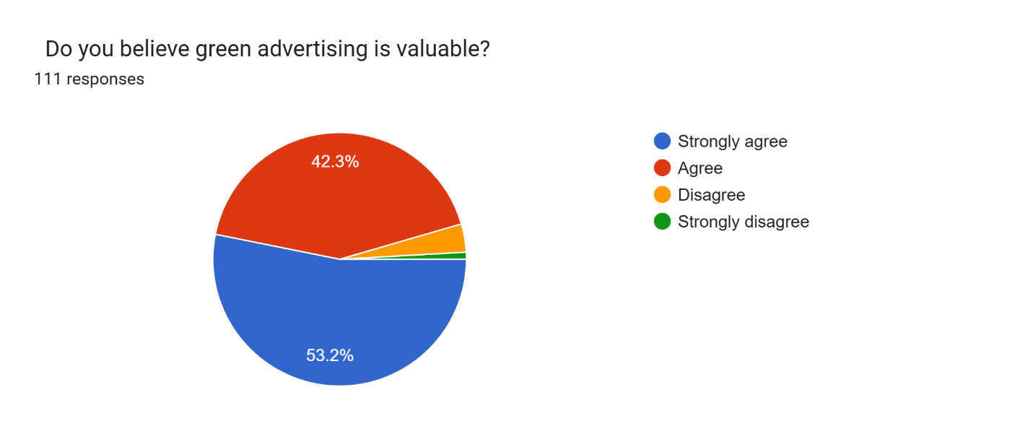

**Table 5.15 shows the percentage of  Do you believe green advertisements are always trustworthy?**

|  |  |
| --- | --- |
| Response Option | Percentage |
| Strongly Agree | 17.3% |
| Agree | 25.5% |
| Disagree | 53.6% |
| Strongly Disagree | 3.6% |

The survey indicates skepticism about green advertisements, with 53.6% disagreeing with their trustworthiness. Only 17.3% strongly agree, while 25.5% agree, showing that most consumers question eco-label advertising claims.

**Figure 5.15 represents the frequency Do you believe green advertisements are always trustworthy using bar graph.**

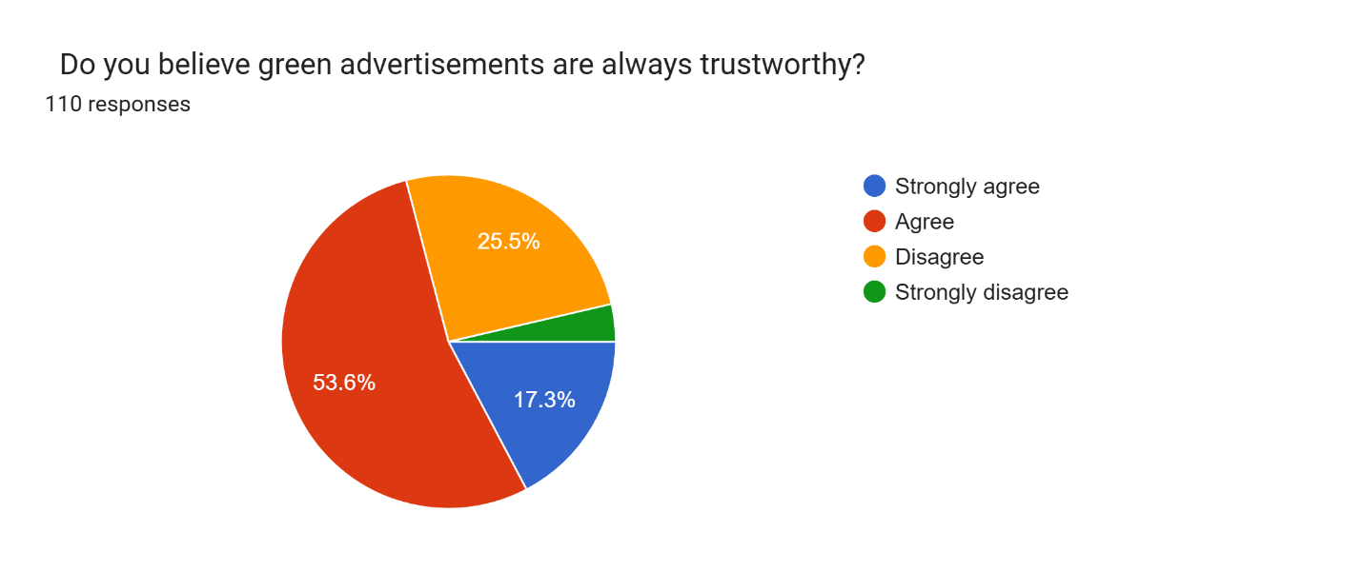

**Table 5.16 shows percentage of  For brands that use green messages in their advertisements, do you think they are good?  .**

|  |  |
| --- | --- |
| Response Option | Percentage |
| Strongly Agree | 19.8% |
| Agree | 11.7% |
| Disagree | 66.7% |
| Strongly Disagree | 1.8% |

**.**

The majority (66.7%) disagree that brands using green messages are inherently good, indicating skepticism. Only 19.8% strongly agree, suggesting trust issues with eco-friendly branding in advertisements.

**Figure 5.16 represents the frequency of** **For brands that use green messages in their advertisements, do you think they are good using Bar graph**

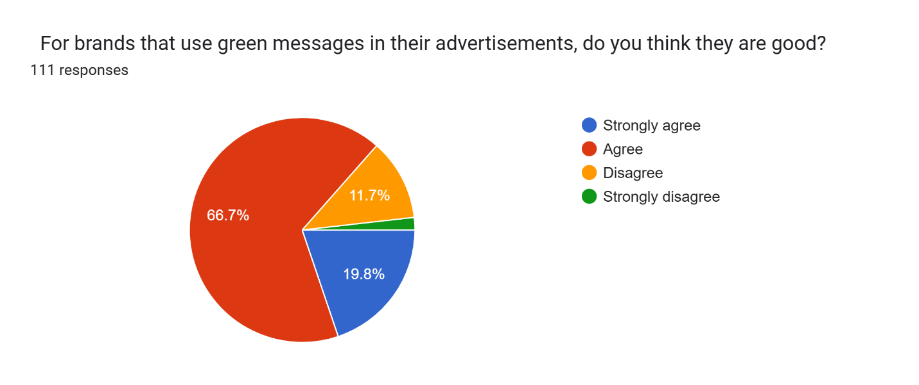

**Table 5.17 shows the percentage of Do you plan to purchase eco-labeled products in the future?**

|  |  |
| --- | --- |
| Response Option | Percentage |
| Yes, definitely | 50.9% |
| Yes, possibly | 43.8 |
| No, not likely | 2.7% |
| No, definitely not | 2.7% |

A majority (50.9%) are highly likely to purchase eco-labeled products, while 43.8% are open to it. Only a small percentage are unlikely or unwilling, indicating strong consumer interest in sustainability.

**Figure 5.17 shows frequency of Do you plan to purchase eco-labeled products in the future using Bar graph.**

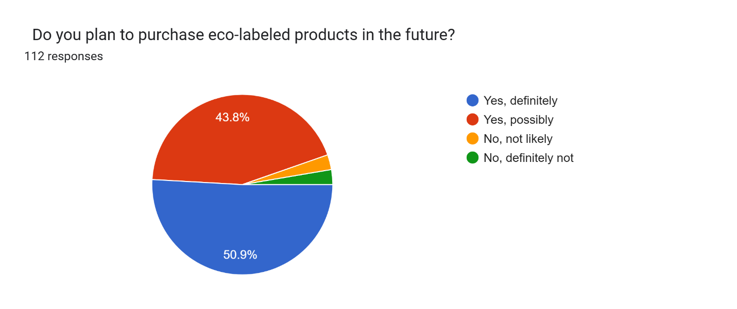

**Table 5.18 The percentage of you willing to purchase more eco-labeled products while shopping?**

|  |  |
| --- | --- |
| Response Option | Percentage |
| Yes, definitely | 43.8% |
| Yes, possibly | 46.4% |
| No, not really | 6.3% |
| No, definitely not | 3.6% |

A majority (43.8% definitely, 46.4% possibly) are willing to purchase more eco-labeled products, showing strong consumer interest in sustainability. Only a small percentage are hesitant or unwilling.

**Figure 5.18 represents frequency of** **you willing to purchase more eco-labeled products while shopping using Pie graph**

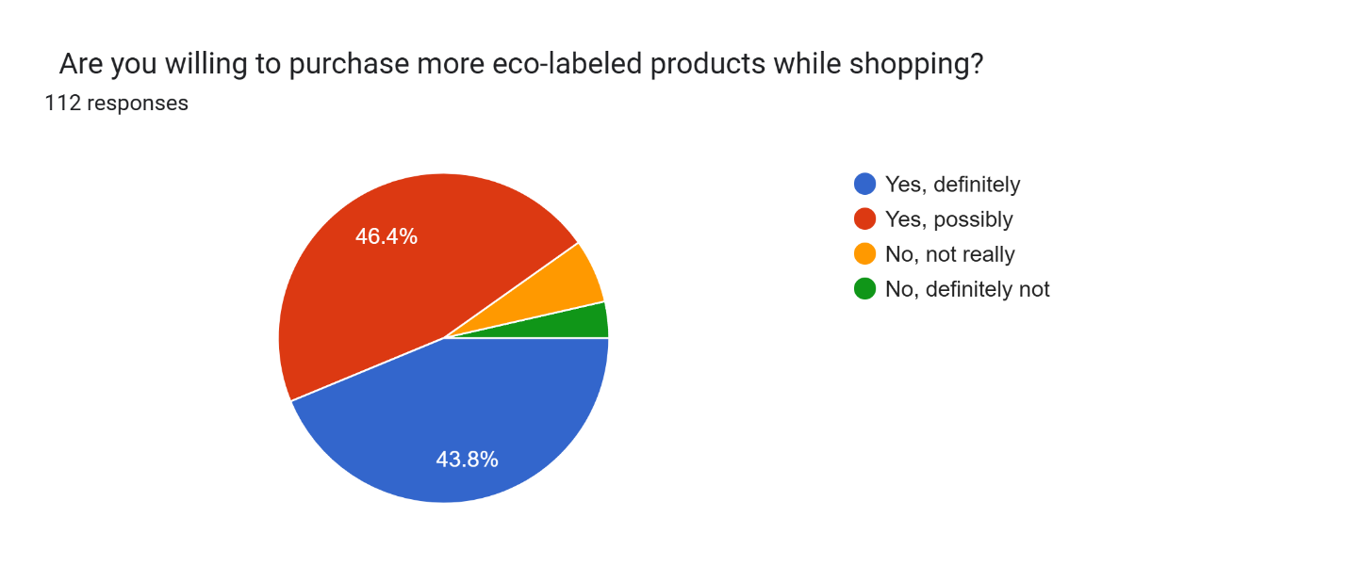

**Table 5.19 represents percentage Do you intend to pay more for eco-labeled products?  .**

|  |  |
| --- | --- |
| Response Option | Percentage |
| Yes, definitely | 31.5% |
| Yes, possibly | 44.1% |
| No, not really | 18% |
| No, definitely not | 6.3% |

The majority (75.6%) are open to paying more for eco-labeled products, with 31.5% definitely willing. However, 18% are hesitant, and a small portion is unlikely to pay extra.

**Figure 5.19 Represents frequency of Do you intend to pay more for eco-labeled products using Pie graph**

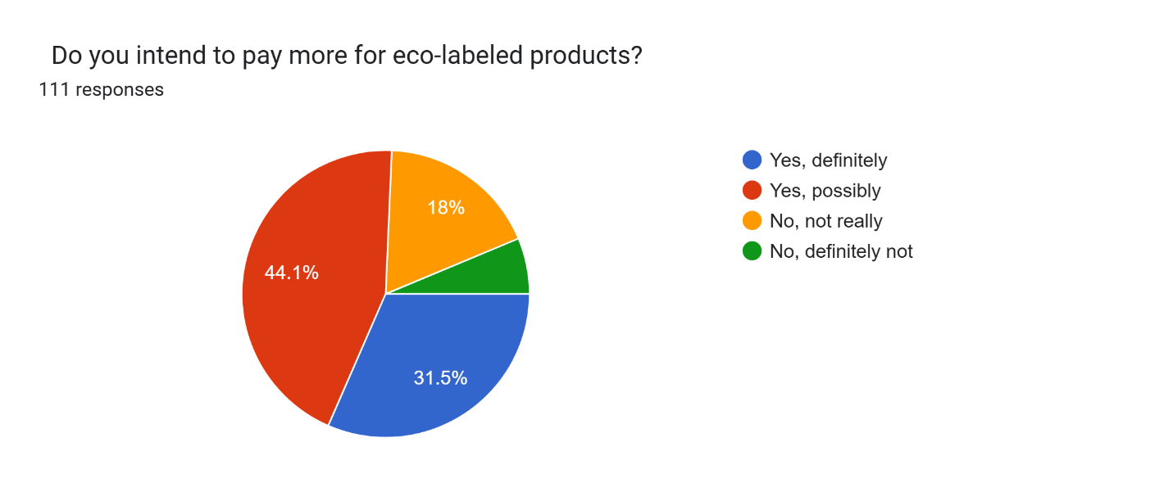

**.**

**CHAPTER-6**

**FINDINGS & LIMITATIONS**

**FINDINGS:**

1. **People Know About Eco-Labels, But Not Deeply**Most participants are familiar with eco-labels, and many even feel they understand them fairly well. But there's still a large group that only has a basic understanding, which shows there's room for better communication about what these labels really mean.
2. **Positive Attitudes Toward Going Green**  
   The majority of respondents expressed a genuine interest in choosing environmentally friendly products. Many said they had already switched products for ecological reasons or often choose the more eco-friendly option when shopping.
3. **Skepticism About Green Ads**  
   While people support the idea of promoting sustainability, they’re not entirely sold on the honesty of green advertising. Over half of the respondents felt that green ads can be misleading or exaggerated, which suggests a trust gap between brands and consumers.
4. **Eco-Labels Do Influence Buying Decisions**  
   A strong number of people said they are likely—or even definitely planning—to buy eco-labeled products in the future. Many are even open to paying more for such products, which shows that consumers value sustainability, provided the claims are trustworthy.
5. **Consumers Want Transparency**  
   Almost everyone agreed that brands should clearly communicate the environmental benefits of their products. This highlights a growing expectation from consumers for brands to be open and honest about their eco-efforts.

**LIMITATIONS:**

1. **Limited and Uneven Sample**  
   The study only included 112 people, mostly from Greater Noida, and most were young and male. This doesn’t give us a full picture of what people from other age groups, regions, or backgrounds might think.
2. **Convenience Sampling May Skew Results**  
   Since participants were chosen based on ease of access (like social media connections), the results might be biased toward a certain type of consumer—those who are already online and somewhat aware.
3. **Self-Reported Opinions Can Be Tricky**  
   All data came from surveys where people shared their own opinions. There's always a chance that respondents gave socially desirable answers, saying what they think sounds good rather than what they actually do.
4. **Intentions vs. Reality**  
   The study focuses on what people *say* they would do, not what they actually *do*. It would be even stronger with real-world behavior tracking or observational data.
5. **Local Focus Limits Broader Application**  
   Because this study focused on just one city, the insights may not reflect what people in other parts of India—or the world—think or do about eco-labels and green advertising.

**CHAPTER-7**

**CONCLUSIONS & RECOMMENDATIONS**

**CONCLUSION:**

This study highlights that people are increasingly aware of and interested in making eco-friendly choices, especially when it comes to the products they buy. Eco-labels and green advertising do play a big role in shaping those choices—but not always in the way we might expect. While many consumers show a strong willingness to support sustainable products, their actual buying decisions are often influenced by how clearly the information is presented and how much they trust it.

Many respondents in this study said they look for eco-friendly options and even feel good about supporting such brands. But at the same time, there’s still some confusion and skepticism—some people don’t fully understand what the labels mean or question whether the ads are truly honest. This shows that while the intent to buy green is there, better communication and greater transparency are needed to turn that intent into action.

Overall, the response to eco-labels and green advertising is encouraging. Most people are open to making environmentally conscious choices and even willing to spend a little more for products they believe in. This offers a great opportunity for brands to step up—by being clear, genuine, and consistent in their messaging—to build trust and drive more meaningful change through consumer behavior.

**RECOMMENDATIONS:**

1. **Make Eco-Labels Simpler and Clearer**  
   A lot of people have seen eco-labels but don’t really understand what they mean. Brands should use easy-to-read language, clean visuals, and clear symbols on packaging to help people quickly get the message.
2. **Be Honest and Transparent**  
   Many consumers are skeptical about green advertising—they’re not sure if brands are really as eco-friendly as they claim. Companies need to be upfront and provide proof, like certifications or third-party endorsements, to build trust.
3. **Educate, Don’t Just Advertise**  
   Instead of just saying “we’re green,” brands should use campaigns to educate people about why eco-labels matter. Whether it’s through social media, short videos, or in-store materials, the more people know, the more they’ll care.
4. **Back Up Green Ads with Real Evidence**  
   If a company says a product is eco-friendly, it should also show *how*. That could be with a behind-the-scenes look at the production process or details about how much waste or energy was saved.
5. **Focus on Young Shoppers**  
   Young people (especially those between 18 and 25) are really paying attention to sustainability. Brands should meet them where they are—on Instagram, YouTube, and other digital platforms—with content that speaks their language.
6. **Make It Easier to Spot Eco-Friendly Products**  
   If customers have to hunt for green products, they’re less likely to choose them. Retailers and brands can help by using clearer labels, green tags, or even dedicated shelf space to highlight eco-friendly options.
7. **Help People Feel Good About Paying a Bit More**  
   Many are willing to spend a little extra for eco-labeled products, but they want to know it’s worth it. Show them how their purchase helps the planet—whether it’s saving water, reducing plastic, or supporting ethical labor.
8. **Team Up with Trusted Organizations**  
   Partnering with government programs or well-known environmental groups can make eco-labels more trustworthy. When people see a familiar name backing a product, they feel more confident in buying it.
9. **Look at What People *Do*, Not Just What They *Say***  
   It’s great that people say they care about the environment, but future studies—and even brands—should pay attention to real buying behavior. Loyalty cards, online orders, or receipts can offer better insights.
10. **Keep It Real—Avoid Greenwashing**  
    Nobody likes to feel misled. If a brand is serious about sustainability, it should communicate honestly—not exaggerate or sugarcoat. Being real about both wins and challenges earns respect and loyalty.